**DESIGN PHASE & TESTING PHASE**

**DOCUMENTATION FOR USE CASE DIAGRAM**

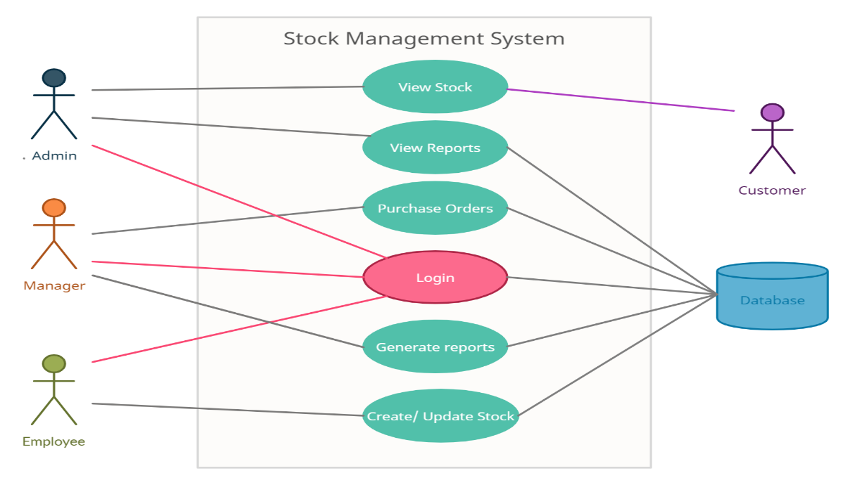

* The Stock management system use cases are View Stock, View Reports, Purchase orders, Login, Generate Reports, Create/Update stock.
* The Actors in the use case diagram are Admin, Manager, Employee, Customer and Database.
* Admin and customer can view the stock
* Employee, Manager and Admin login with their credentials to access the Database.
* Admin can view reports of stock from the Database.
* Manager purchases orders and he generates reports of stock from Database.
* Update/Create stock from Database is done by an Employee.
* The actors using the use case are denoted by the arrow.

**DOCUMENTATION FOR STATE DIAGRAM**

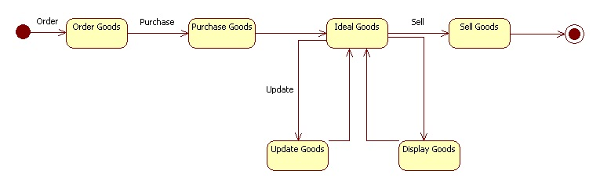

* In this State diagram of the Stock management system we deal with the ordering process.
* In this state diagram we have attributes like order goods,purchase goods,ideal goods,sell goods,update goods,display goods.
* The customer orders the goods which we need and then purchases them.
* The Employee updates the goods which are available.
* He keeps updating the goods and their availability.
* This process ends with selling the goods ordered by the customer.

**DOCUMENTATION OF COMMUNICATION DIAGRAM** 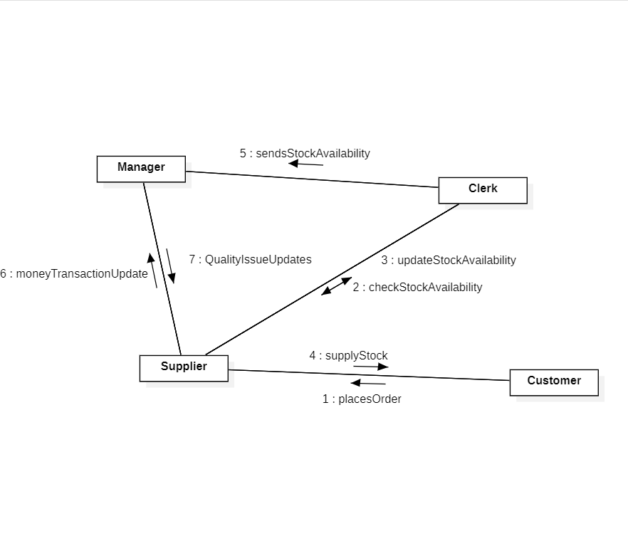

→ The customer first places the order whose request is received by supplier

→ Supplier then checks if the stock is available with the clerk and gets the update

→ With this the supplier supplies the stock to the customer and the clerk sends the stock availability to the manager who updates the quality issues

→ The customer's money transaction is updated to the manager by the supplier.

**DOCUMENTATION OF CLASS DIAGRAM**

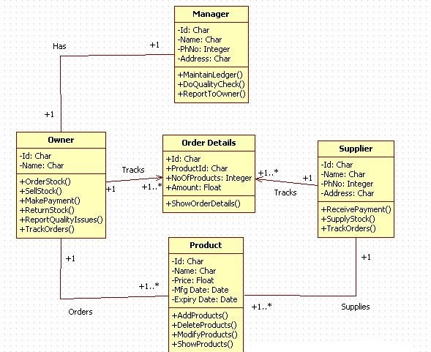

* The Manager has attributes such as name,id,phone number,address and methods such as maintaining ledger,do quality check,report to owner.Owner has Manager.
* The Owner has attributes such as name,id and methods such as order stock ,sell stock,make payment,return stock,report quality issues,track orders.Owner tracks order details and orders products.
* Product has attributes such as name,id,price,dates and methods such as adding products,delete products,modify products and showing products.
* The Supplier has attributes such as name,id,phone number,address and methods such as receiving payment,supplying stock,, tracks the order.Supplier supplies the product.
* Order Details has attributes such as id,product id,number of products,amount and methods such as show order details.Order details are tracked by supplier and the owner.

**DOCUMENTATION FOR DEPLOYMENT DIAGRAM**

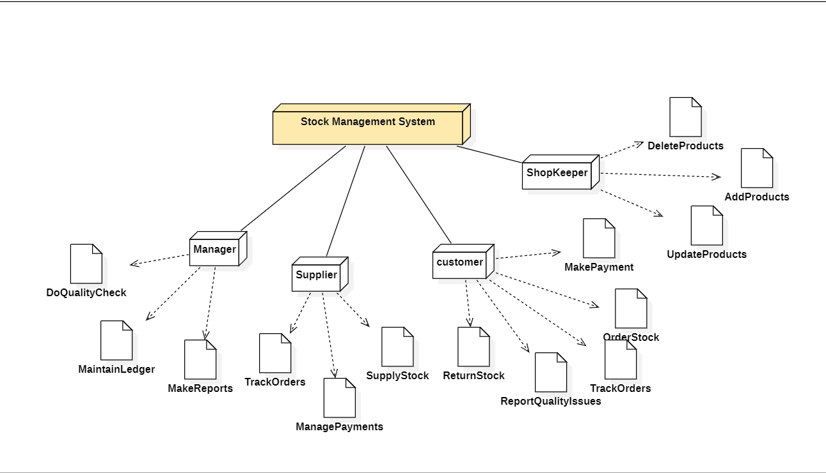

**.** The stock management system has a manager , supplier, customer , shopkeeper .

**.** Manager**:** Manger do quality check of the product , maintain ledger and make reports of the products.

**.**Suppliers : Supplier track orders , manage payments and supply stock.

**.** Customer : customer return stock , report quality issues if there is any issue with the product , track order , make payment for the product received.

**.** Shopkeeper : Update product’s , add product’s , delete Product’s .

**DOCUMENTATION OF COMPONENT DIAGRAM**

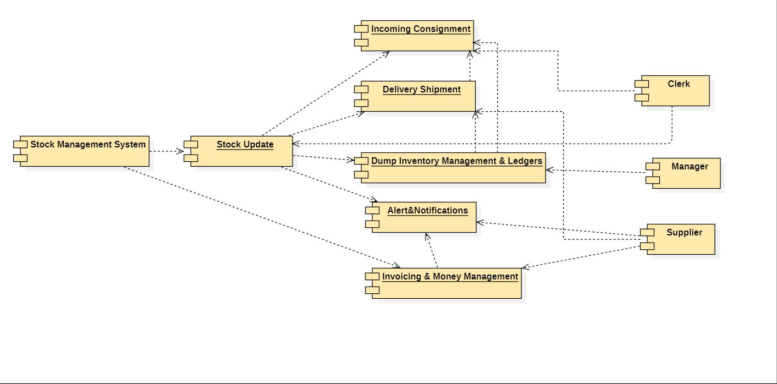

* Stock management system has the components like stock update which contains incoming consignment,delivery shipment,dump inventory management ,alert notifications and invoicing ,money management.
* Clerk takes care of stock updates and the manager manages dump inventory and ledgers .
* Supplier gets notified with alert notifications. and invoicing and take care of delivery shipment.

**DOCUMENTATION OF ACTIVITY DIAGRAM :**

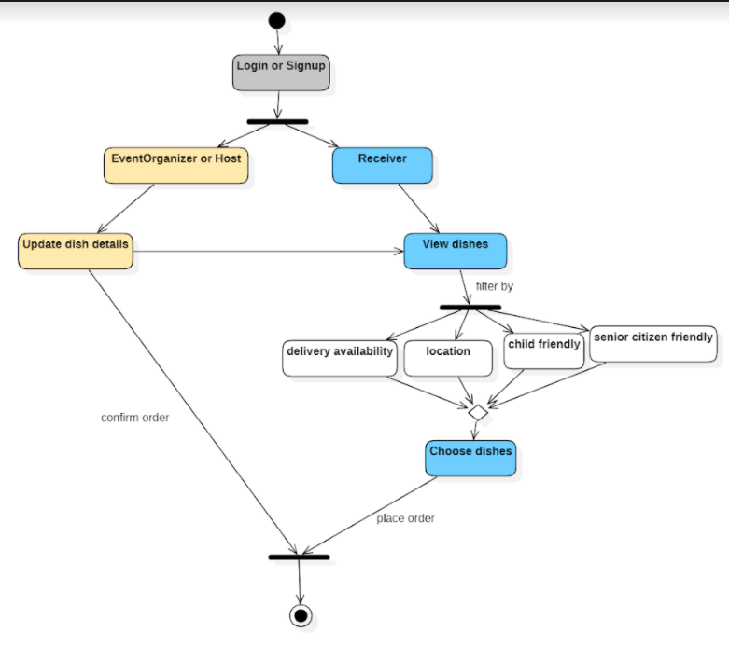

* Activity diagram is basically a flowchart to represent the flow from one activity to another activity. The activity can be described as an operation of the system.
* Before drawing an activity diagram, we should identify the following elements −activities,association,conditions and constraints.
* Once the above-mentioned parameters are identified, we need to make a mental layout of the entire flow. This mental layout is then transformed into an activity diagram.
* In the above diagram the host and receiver can login or signup wherein the host can update the details of the dish and receiver can view the dishes and choose them accordingly and place the order and logout.